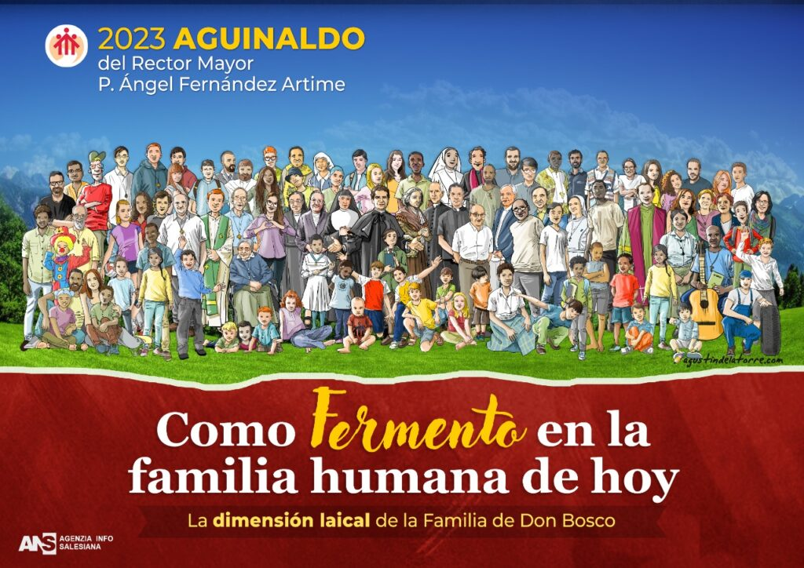
SALESIAN FAMILY
VIA MARSALA, 42 – 00185 ROME

Indications for group work-1
Friday morning
REGARDING THE STRENNA 2023
Language groups

1. Devote the first few minutes to personal presentation of the members of the group: name, where from, Salesian Family group, reason for taking part in the Conference,
2. Each participant in the group shares two most significant aspects of the Strenna that is of most help to us FOR VALUING THE LAY DIMENSION of the Salesian Family. In the end the group chooses THE THREE MOST OUTSTANDING ASPECTS.
3. Each group participant indicates TWO CHALLENGES for living the lay dimension within the Salesian Family in a better way. In the end the group chooses THE THREE MOST OUTSTANDING ASPECTS.
Working procedure
A. The group elects a secretary (S) and a moderator (M)
- The secretary takes summary notes of what is being talked about in the group
- The secretary sends this by email gsfs@famigliasalesiana.org
  - Indicates the working group.
  - Points out the 3 most outstanding aspects that help to enhance the lay dimension of the Salesian Family.
  - Indicates the 3 challenges that secularism presents to our Salesian Family.
FORMATION OF LANGUAGE GROUPS

ITALIAN 1

SPANISH 1

FRENCH 1

ENGLISH 1

PORTUGUESE 1

